**CLASS ELEMENT FACEBOOK**

* **SELECT MODE VIEW ALL**

**box_menu_select_mode_view**

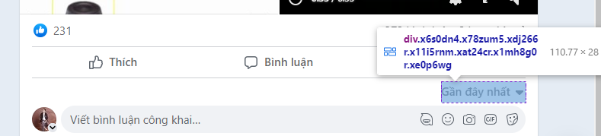

**button_menu**

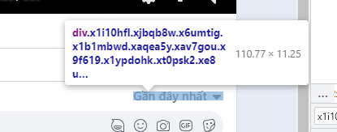

**menu_item**

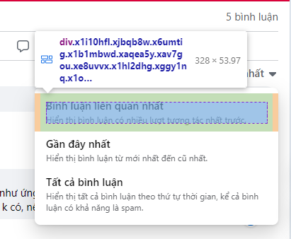

* **SHOW ALL COMMENT**

**list_button_more**

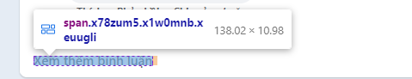

* **SHOW MORE TEXT**

**list_button_more_text**

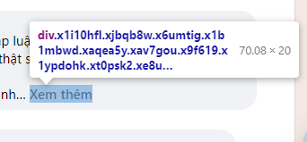

**box_type_comment**

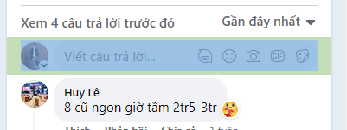

* **GET ALL COMMENT IN POST**

**box_total_comment**

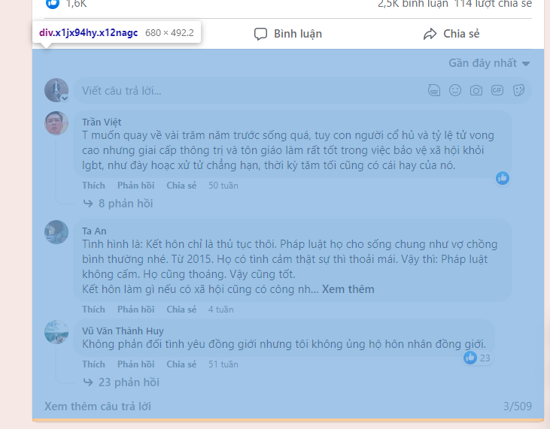

* **GET MAIN COMMENT**

**big_box_main_comment**

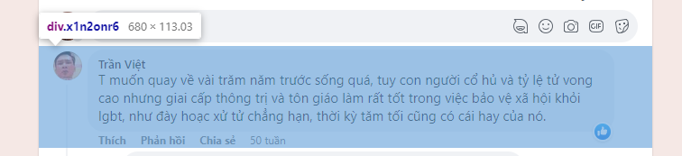

**small_box_main_comment**

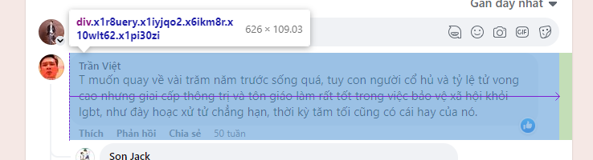

* **GET MAIN REPLY**

**total_box_reply**

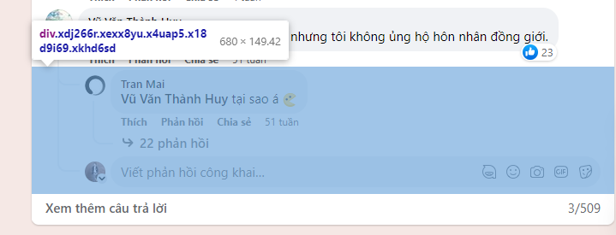

**big_box_main_reply_1**

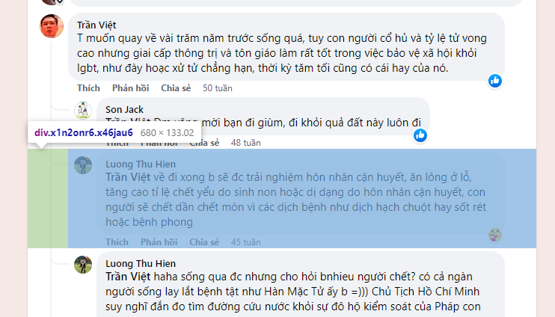

**big_box_main_reply_2**

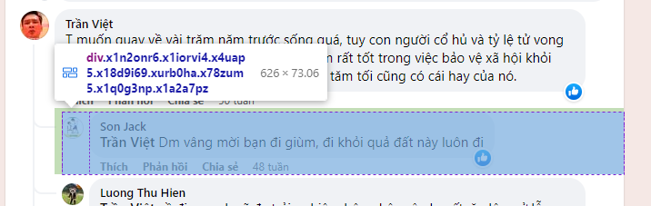

**small_box_main_reply**

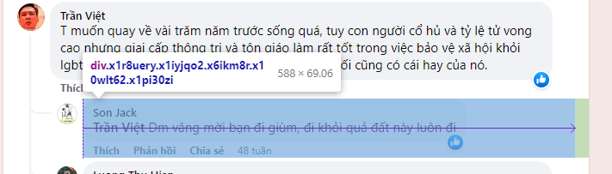

* **GET MINI REPLY**

**big_box_mini_reply**



**small_box_mini_reply**



* **GET DATA FOR BOX COMMENT**

**user_comment**

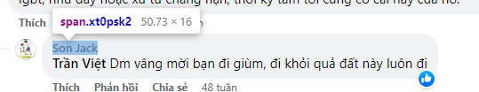

* **GET TEXT FOR BOX COMMENT**

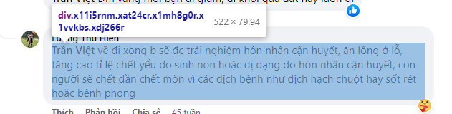

* **GET TAGS FOR BOX COMMENT**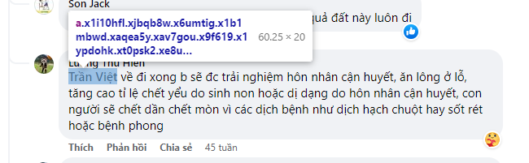
* **GET ATTACHMENTS FOR BOX COMMENT**

**box_attachment**

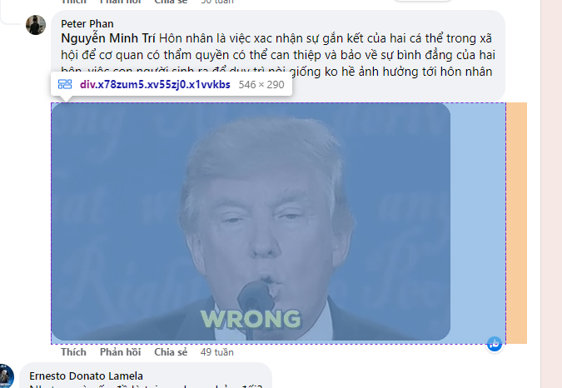

**box_image_attachment**

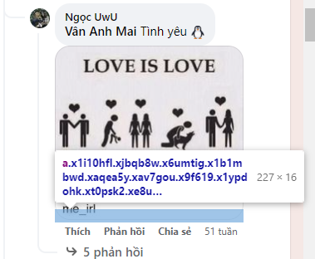



* **GET LINK TO REPLY**

**box_link**

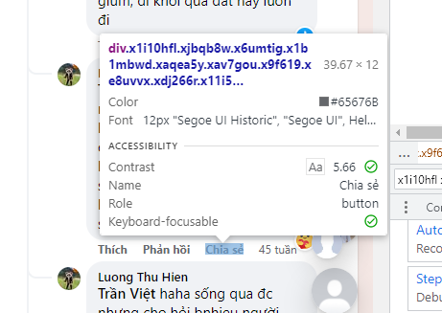

* **GET NUMBER COMMENT**

**box_number_comment**

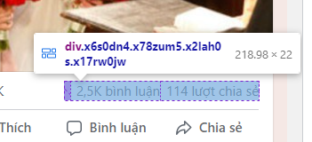

**box_text_number_comment**

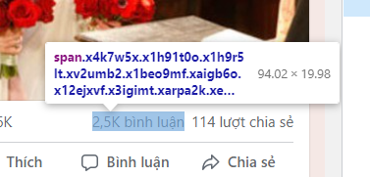

* **CLICK REPLY BUTTON**

**button_reply**

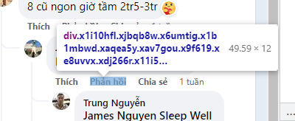

* **DETECT BOX REPLY**

